**Module I : AI and Machine Learning — Applications and Foundations**

1. AI- terminologies:(link: https://www.tutorialspoint.com/artificial_intelligence/artificial_intelligence_terminology.htm)

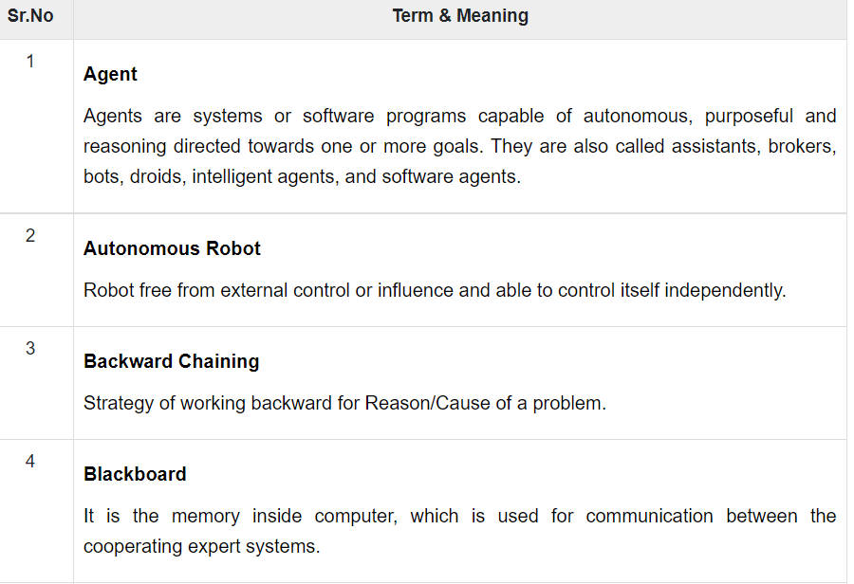

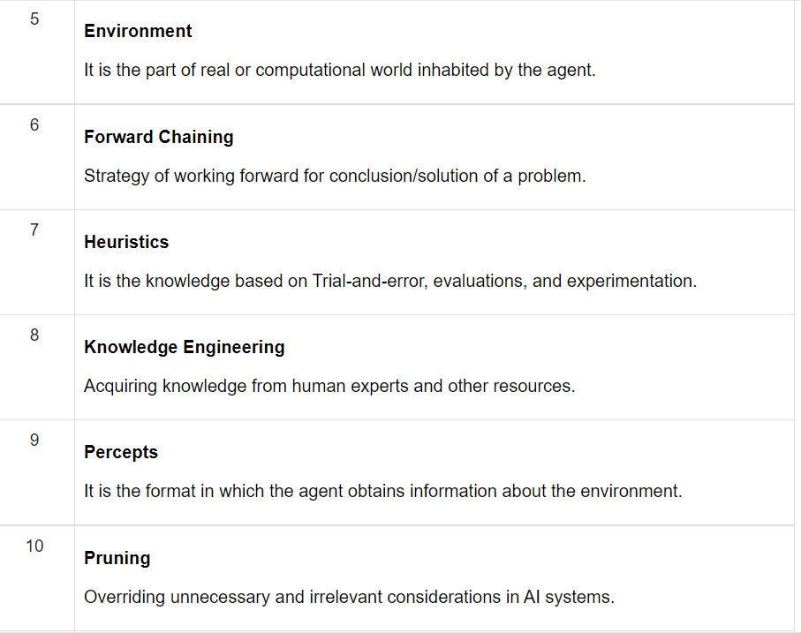

1. computational models of intelligence:(link: https://www.slideshare.net/pedroalmir/computational-intelligence-concepts-and-applications-using-athena)

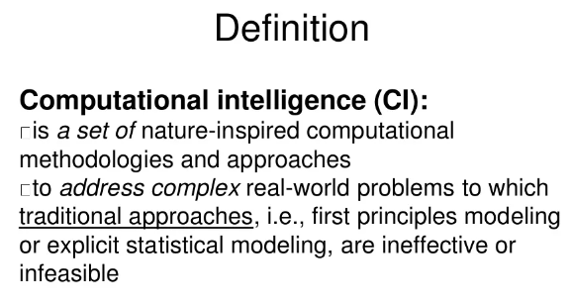

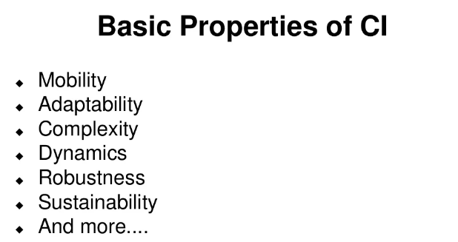

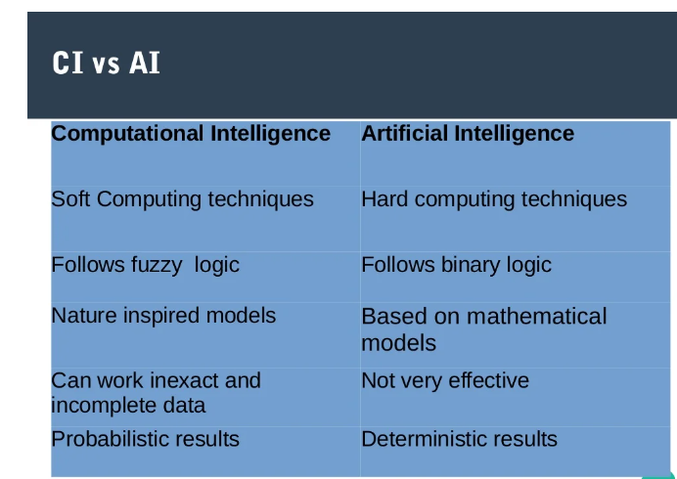

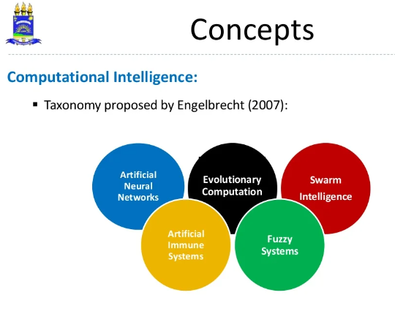

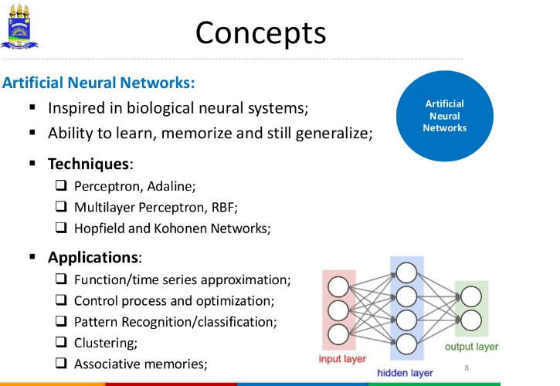

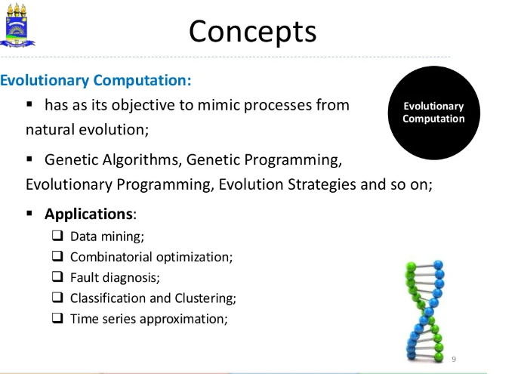

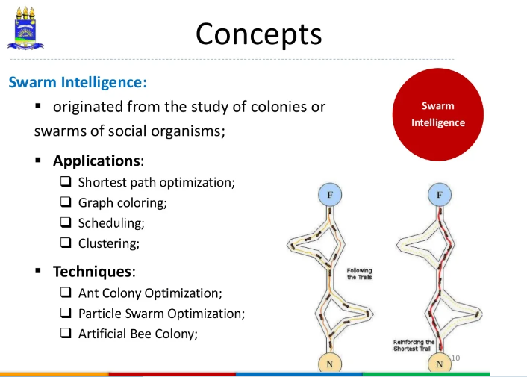

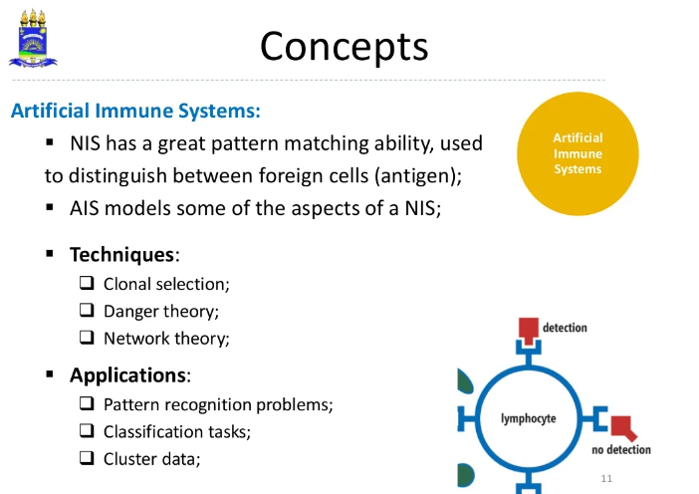

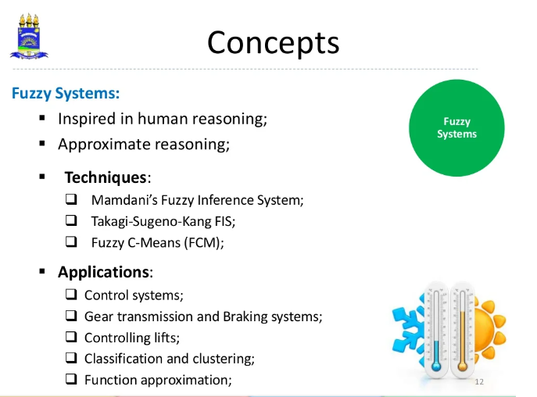

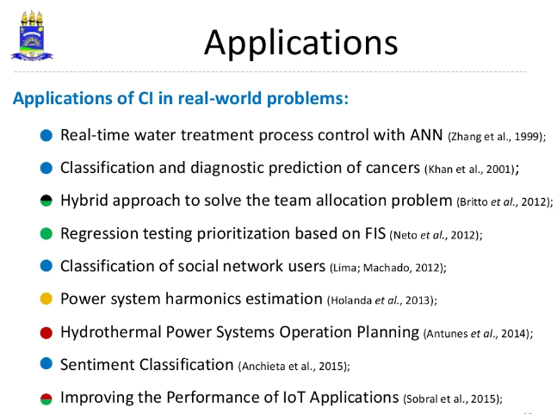

1. Conceptual framework from Cognitive(link: <https://www.youtube.com/watch?v=Zsl7ttA9Kcg&ab_channel=edureka%21>)
2. Linguistics: link(<http://www.ep.liu.se/ecp/048/003/ecp1048003.pdf> & <https://medium.datadriveninvestor.com/artificial-intelligence-and-linguistics-dc9eeee775dd>
3. Information Theory:(link: https://towardsdatascience.com/must-know-information-theory-concepts-in-deep-learning-ai-e54a5da9769d#:~:text=Information%20theory%20is%20an%20important,%3A%20calculus%2C%20probability%20and%20statistics.)

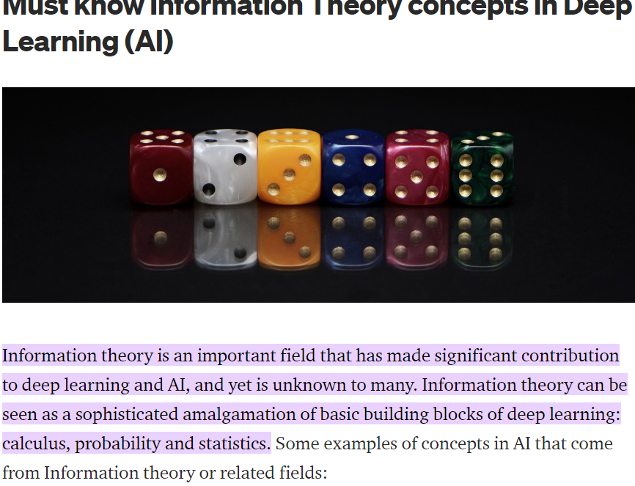

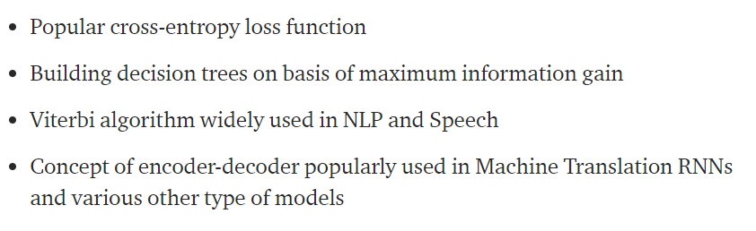

6.Neuroscience:(link: <https://towardsdatascience.com/the-fascinating-relationship-between-ai-and-neuroscience-89189218bb05>)

7. foundation of AI link(https://www.slideshare.net/MeghaSharma504/foundation-of-ai-248193859)